SQL Assignment – 1

Products Table :

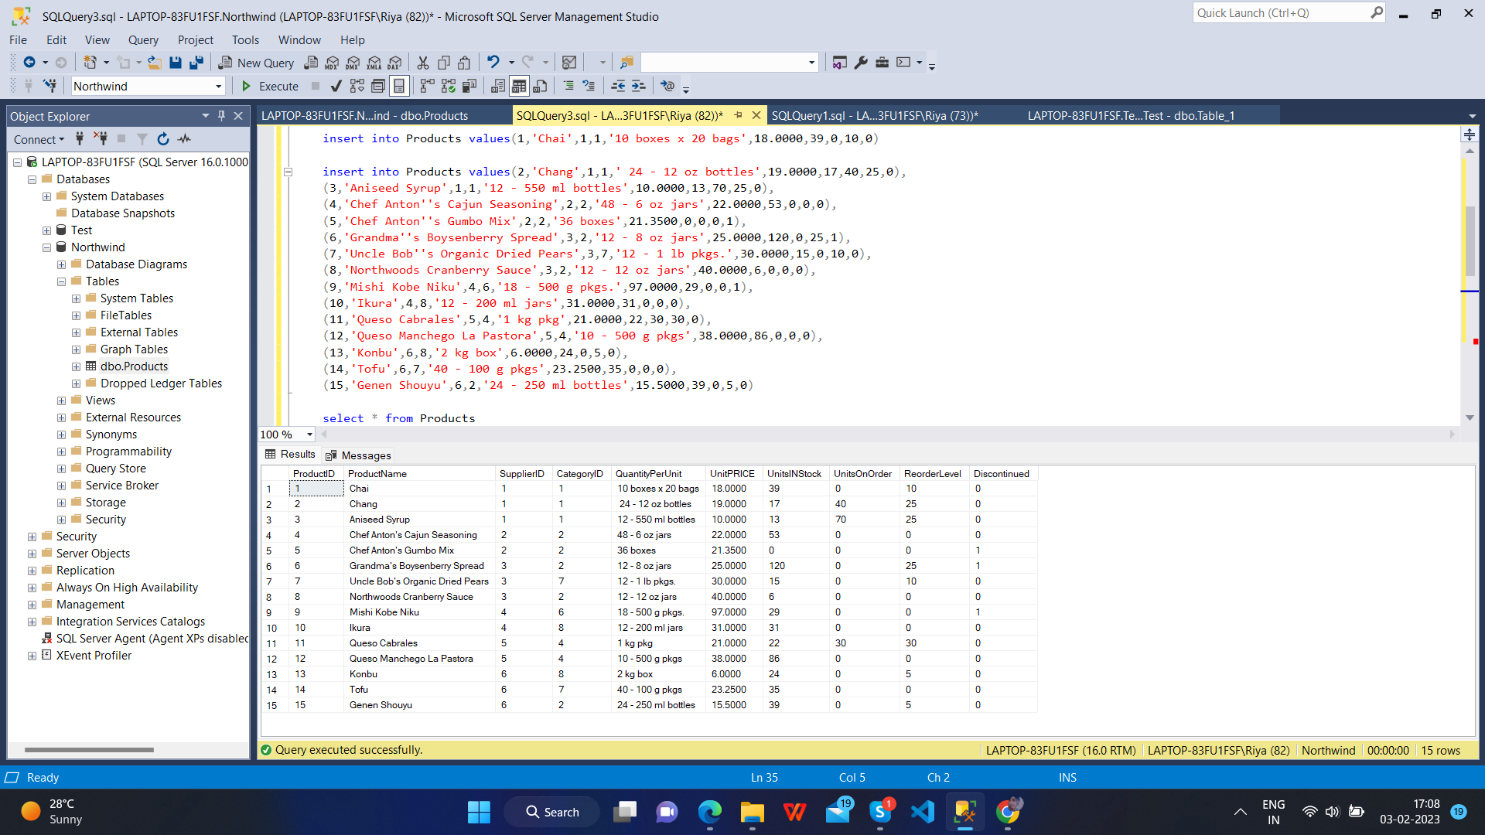

**Query for creating table :**

CREATE TABLE Products(

ProductID INT not null PRIMARY KEY,

ProductName varchar(40),

SupplierID int not null,

CategoryID int not null,

QuantityPerUnit varchar(20) not null,

UnitPRICE Decimal(10, 4),

UnitsINStock smallint not null,

UnitsOnOrder smallint not null,

ReorderLevel smallint not null,

Discontinued bit

)

**Query for Inserting data into table :**

insert into Products values(1,'Chai',1,1,'10 boxes x 20 bags',18.0000,39,0,10,0)

insert into Products values(2,'Chang',1,1,' 24 - 12 oz bottles',19.0000,17,40,25,0),

(3,'Aniseed Syrup',1,1,'12 - 550 ml bottles',10.0000,13,70,25,0),

(4,'Chef Anton''s Cajun Seasoning',2,2,'48 - 6 oz jars',22.0000,53,0,0,0),

(5,'Chef Anton''s Gumbo Mix',2,2,'36 boxes',21.3500,0,0,0,1),

(6,'Grandma''s Boysenberry Spread',3,2,'12 - 8 oz jars',25.0000,120,0,25,1),

(7,'Uncle Bob''s Organic Dried Pears',3,7,'12 - 1 lb pkgs.',30.0000,15,0,10,0),

(8,'Northwoods Cranberry Sauce',3,2,'12 - 12 oz jars',40.0000,6,0,0,0),

(9,'Mishi Kobe Niku',4,6,'18 - 500 g pkgs.',97.0000,29,0,0,1),

(10,'Ikura',4,8,'12 - 200 ml jars',31.0000,31,0,0,0),

(11,'Queso Cabrales',5,4,'1 kg pkg',21.0000,22,30,30,0),

(12,'Queso Manchego La Pastora',5,4,'10 - 500 g pkgs',38.0000,86,0,0,0),

(13,'Konbu',6,8,'2 kg box',6.0000,24,0,5,0),

(14,'Tofu',6,7,'40 - 100 g pkgs',23.2500,35,0,0,0),

(15,'Genen Shouyu',6,2,'24 - 250 ml bottles',15.5000,39,0,5,0)

**Q – 1 : Write a query to get a Product list (id, name, unit price) where current products cost less than $20.**

/*Query 1*/

select ProductID, ProductName, UnitPrice from Products where(UnitPrice<20 and Discontinued=0)

**Output :**

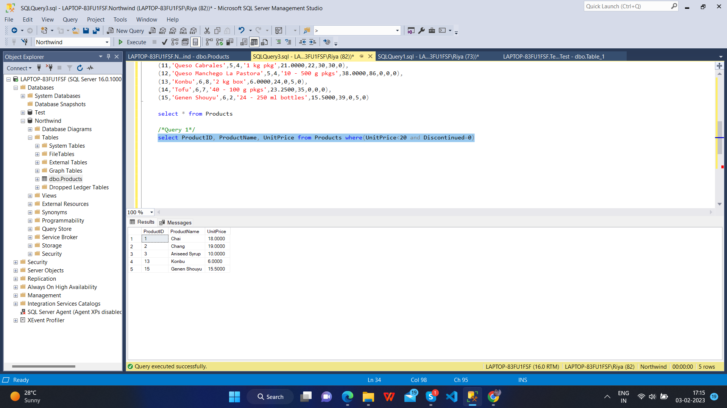

**Q – 2 : Write a query to get Product list (id, name, unit price) where products cost between $15 and $25**

/*Query 2*/

select ProductID, ProductName, UnitPrice from Products where(UnitPrice between 15 and 25)

**Output :**

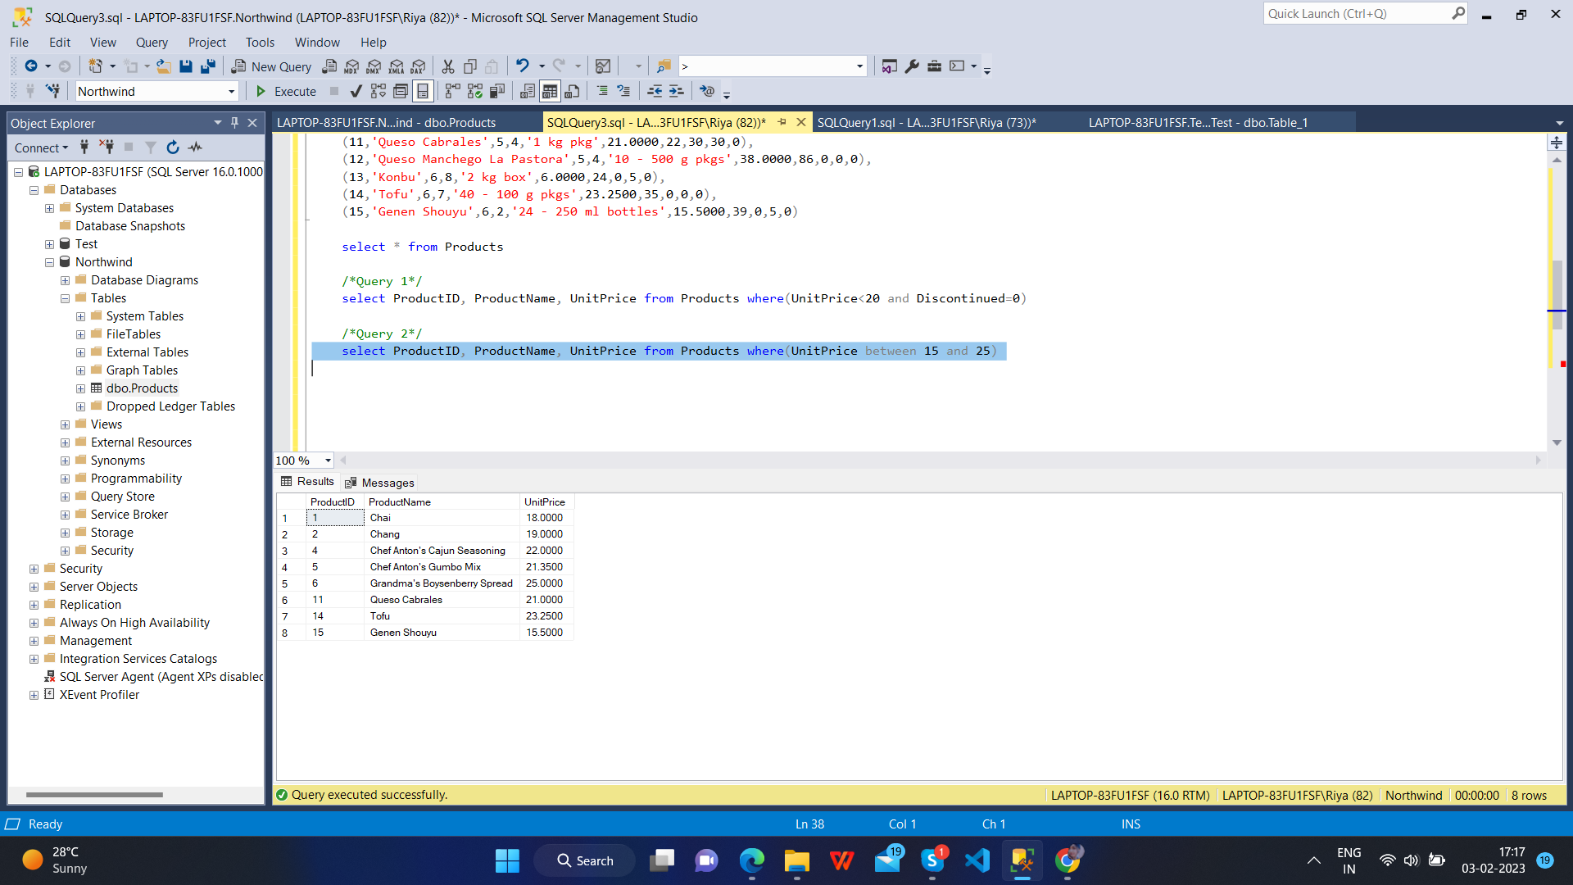

**Q – 3 : Write a query to get Product list (name, unit price) of above average price.**

/*Query 3*/

select ProductName, UnitPrice from Products where((UnitPrice)> (Select AVG(UnitPrice) from Products))

**Output :**

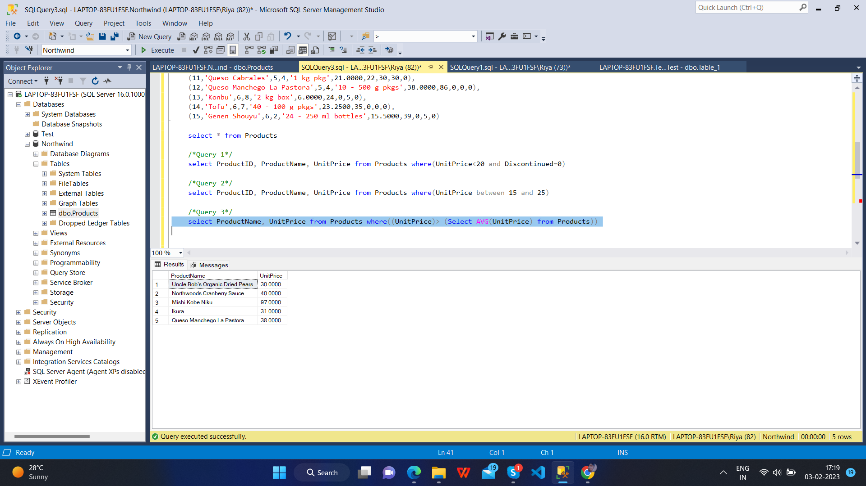

**Q – 4 : Write a query to get Product list (name, unit price) of ten most expensive products**

/*Query 4*/

select Top 10 ProductName, UnitPrice from Products order by UnitPrice desc

**Output :**

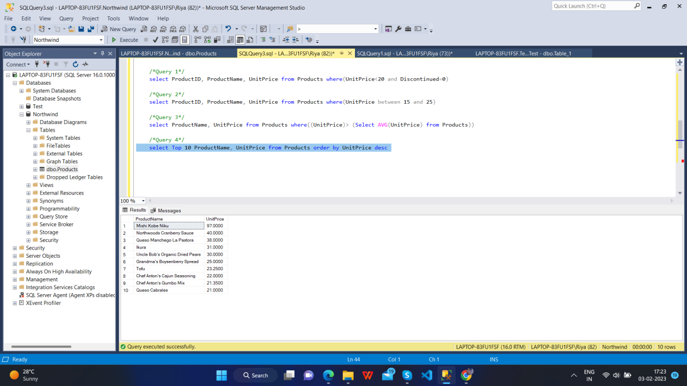

**Q – 5 : Write a query to count current and discontinued products**

/*Query 5*/

select COUNT(ProductName) from Products group by Discontinued

**Output :**

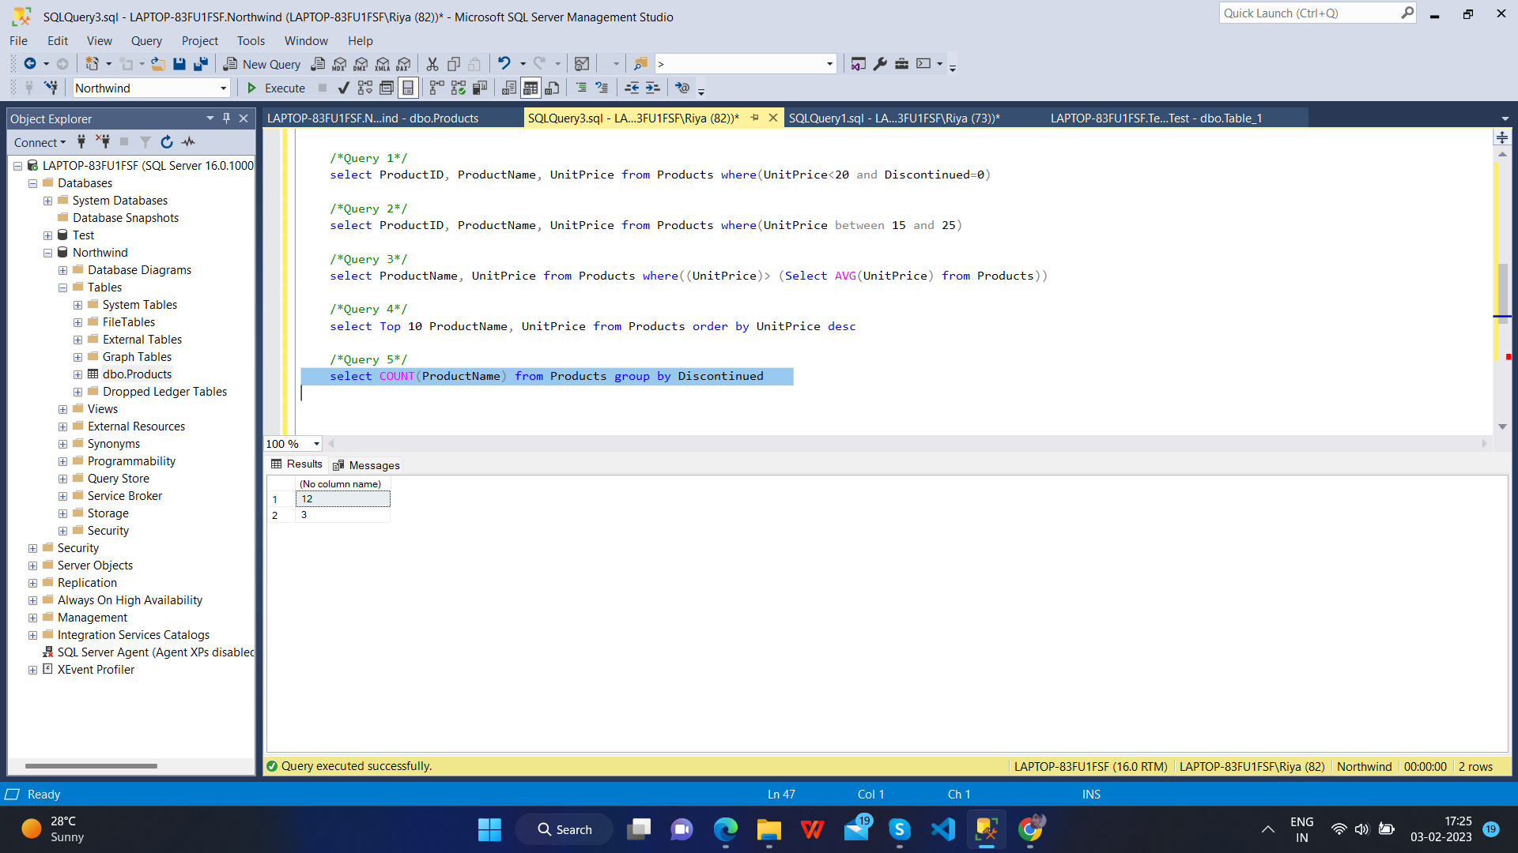

**Q – 6 : Write a query to get Product list (name, units on order , units in stock) of stock is less than the quantity on order**

/*Query 6*/

select ProductName, UnitsOnOrder, UnitsINStock from Products where UnitsINStock < UnitsOnOrder

**Output :**

